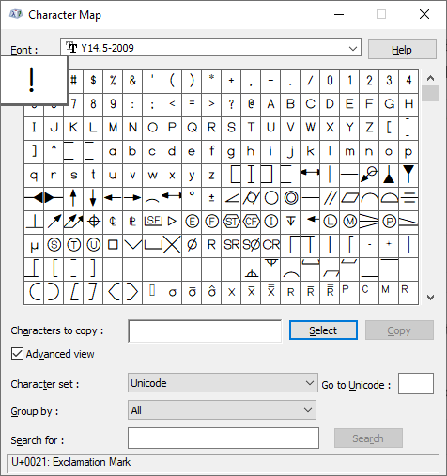

The way the computer displays human readable characters is through fonts. Fonts are simply a package that contains a Glyph (the actual representation of a symbol displayed on the screen) and a corresponding Unicode Character Set (the computer readable part, Unicode is a computer standard). The character map shows which Unicode character maps to which symbol. The IRRS are being exported with a font that is not recognized by windows and the Glyphs display wrong. The Goal of the program is to fix the mapping. The existing program has a font that already works correctly in windows (see picture), but the internal working is not know because we do not have the source code. The goal of the new program is to do the character mapping while allowing users to see the internal source code of the program and instead of having to change the program all you would need to do would be to fix the table doing the character mapping, see below for an example.

|  |  |  |  |
| --- | --- | --- | --- |
| Wrong Symbol | Wrong Unicode Character | Right Symbol | Right Unicode Character |
| | | U+007C | { | U+007B |
| | | U+007C | } | U+007D |
| ⌓ |  |  |  |
|  |  |  |  |